Bob Homer Alice
28 years old 39 years old 9 years old
55 kilos 80 kilos 33 kilos
1.50 mt 1.55 mt 1.20 mt

Compare the following people:
Bob is (YOUNG) than Homer.
Homer is (OLD) than Alice.
Alice is (SLIM) than Bob.
Bob is (SHORT) than Homer.
Homer is (FAT) than Bob.
Alice is (SHORT) than Homer.
Homer is (UGLY) than Alice.
Homer is (SLOW) than Bob.
Bob is (TIDY) than Homer.
Alice is (BEAUTIFUL) than Bob.
Alice has got (LONG) hair than Bob.
Homer can play the guitar (GOOD) than Alice.
Alice can run (FAST) than Homer.
Alice draws (BAD) than Bob.
Bob is (INTELLIGENT) than Homer.
Homer is a (INTERESTING) person than Bob.

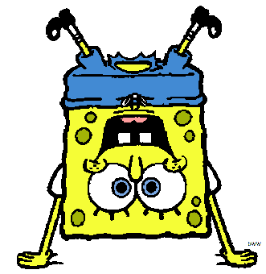
Harry Garfield Sponge Bob
32 years old 10 years old 6 years old
75 kilos 60 kilos 3 kilos
1.90 mt 0.57 mt 0.20 mt
Now, compare the following people:
ex: Harry is older than Garfield. (OLD-YOUNG)
Write ONE word per gap
Garfield Sponge Bob. (YOUNG-OLD)
Sponge Bob Harry. (FAT-SLIM)
Harry Sponge Bob. (SHORT-TALL)
Garfield Harry. (SHORT-TALL)
Garfield Harry. (FUNNY-BORING)
Sponge Bob's eyes Harry's. (SMALL-BIG)
Harry Garfield. (STRONG-WEAK)
Garfield Harry. (BEAUTIFUL-HORRIBLE)
Bob Sponge at sports Garfield. (GOOD-BAD)

© CynWilkinson 2009

