Adjective (Relative) Clause Practice

Choose all the possible correct answers to complete the sentence. Most sentences have more than one correct response.
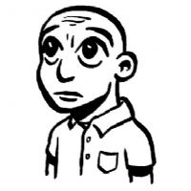
1. Sam is the boy _____ shaved his head--he is completely bald now.
who
that
which
O

2. The food ____ she is buying looks healthy.
who
that
which
O

3. A dishwasher is a machine ____ washes dishes.
who
that
which
O

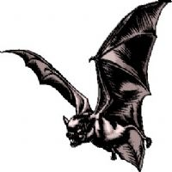
4. The bat is the only mammal ___ can fly.
who
that
which
O

5. Look! That's the singer ___ mother is from my hometown.
whose
who
that
who's
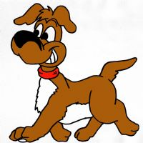
6. I don't like dogs ___ jump on me.
whose
that
whom
O

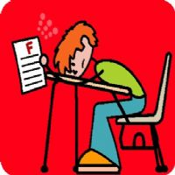
7. I felt bad for the guy ___ failed the exam.
that
which
who
O
8. Jasmine is a flower ____ is white and very fragrent.
which
who
that
O

9. They are filming the girl ___ birthday is today.
whose
that
who
O
10. There's the couple ___ dancing you liked so much.
whose
that
who
O

