At the restaurant Useful phrases
1) The waiter
What can I do for you?
Can I help you?
Can I take your coat?
Have you booked a table?
How many are you?
Would you follow me, please?
Can I take your order, sir/madam?
What would you like to start with?
What would you like to drink/have?
What would you like for dessert?
How would you like your steak? (rare, medium, well done)
Do you want a salad with it?
What kind of dressing?
Anything to drink?
Do you want a dessert?
The burgers are very good.
Sorry, the hamburgers are off.
Is everything all right?
Did you enjoy your meal?
Are you paying together?
May I show you to a table?
If you wait, there'll be a table for you free in a minute.
Do you want vegetables with it?
Why don't you try the pizza?
It'll take about 20 minutes.

2) The guest
A table for two, please.
May we sit at this table?
The menu, please.
What's on the menu?
Do you want fish?
What's Irish Stew like?
We're not ready yet.
The steak for me, please.
Can you bring me the ketchup, please?
A salad, please.
I'll have the same.
That's all, thank you.
Can I have the bill (AE: check), please?
This is on me.
Here you are.
The rest is for you.
Have you got wine by the glass?
I'd prefer red wine.
Please bring us another beer.
Could I have chips (AE: French Fries) instead of salad?
What can you recommend?
Please bring me the bill (AE: check) with my coffee.
I think you've made a mistake.

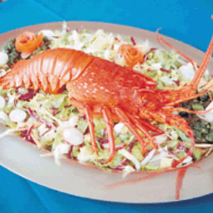
Practice 1: Sample Conversation at the restaurant – Study the following conversation and practice it in pairs.
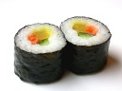
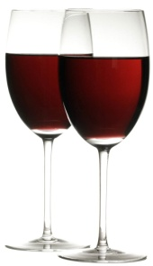
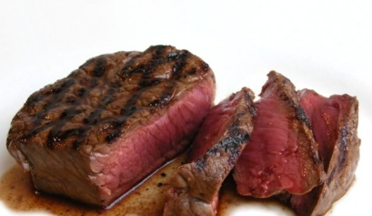
WAITER: Good Evening sir, welcome to our restaurant. GUEST: Good Evening! WAITER: Please be seated, I’m just bringing a glass of water for you. GUEST: Thanks! WAITER: What would you like to have sir? GUEST: What’s your specialty? WAITER: We are known for a delicious Chinese food. GUEST: Please bring one plate of Manchurian with Fried Rice. WAITER: Kindly wait, your order will be delivered within 5-10 minutes. GUEST: OK. WAITER: (After Five Minutes) Here is your order sir. GUEST: Please bring one Coke also. WAITER: Yes sir. GUEST: (After having the meal) The food was quite good and your service also. WAITER: Thanks a lot! GUEST: Please bring the bill. WAITER: Here is the bill sir. GUEST: This is your bill and tip also. WAITER: Thank you, please do visit next time and have very wonderful night. GUEST: I will.
Practice 2: Fill-in-the-blanks from the conversation above with new vocabulary. Practice it in pairs.
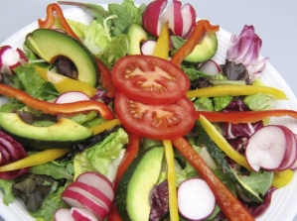
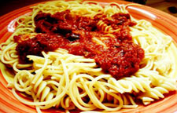
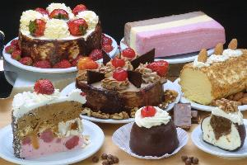
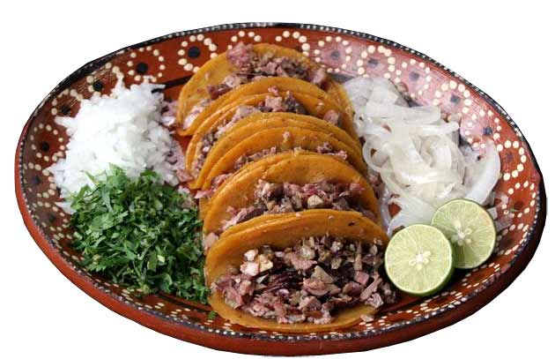
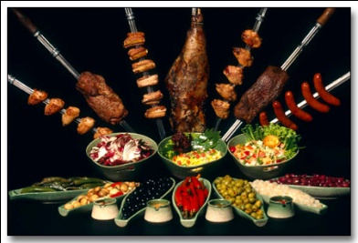
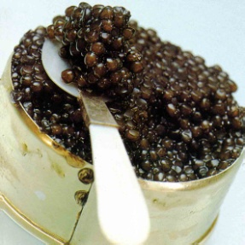
WAITER: Good Evening sir, welcome to our restaurant. GUEST: Good Evening! WAITER: Please be seated, I’m just bringing a _____________for you. GUEST: Thanks! WAITER: What would you like to have sir? GUEST: What’s your specialty? WAITER: We are known for a delicious _____________ food. GUEST: Please bring __________________________________________. WAITER: Kindly wait, your order will be delivered within 5-10 minutes. GUEST: OK. WAITER: (After Five Minutes) Here is your order sir. GUEST: Please bring one ___________________________also. WAITER: Yes sir. GUEST: (After having the meal) The food was quite good and your service also. WAITER: Thanks a lot! GUEST: Please bring the bill. WAITER: Here is the bill sir. GUEST: This is your bill and tip also. WAITER: Thank you, please do visit next time and have very wonderful night. GUEST: I will.
Practice 3: Using some expressions or phrases from the columns on the first page, expand the conversation, with a partner. You can modify it from the beginning to the end.
