CONVERSATION CLUB
LESSON 9
Topic: “Closing a conversation”
Objective: Students will be presented to the topic how to close a conversation in a polite, culturally accepted way, by using the three essential conversational moves.

Warm-up: How do you end a conversation in a polite way? Provide some examples.

Essential moves for closing a conversation:

Pre-closing
It's been nice talking to you.
It's been great talking with you.
I really enjoyed meeting you.
It was nice meeting you, Mr. Brown.
I'm sorry, but I have to go now.
I'm afraid I have to leave now.
Thanks for the information/ the tour/ your time.

Thanks for taking the time to talk with us.

Follow up
I'll give you a call.
I'll send you an e-mail.
I'll put a packet in the mail for you.
We'll send out that information right away.
I'll have my secretary schedule an appointment.
Could you send me a brochure/some more information?
Could I contact you by e-mail/at your office?
How can/do I get in touch with you?

Closing
I look forward to seeing you again.
We'll see you on Friday.
See you next week.
Let me give you my business card.
Here's my e-mail/office number.
Let's keep in touch by e-mail.
We'll be in touch.
Call me if you have any questions.
E-mail me.

Activity 1: In the following conversations, identify the 3 moves or steps required to end a conversation in a polite way.
A: Well, it's been nice talking to you.
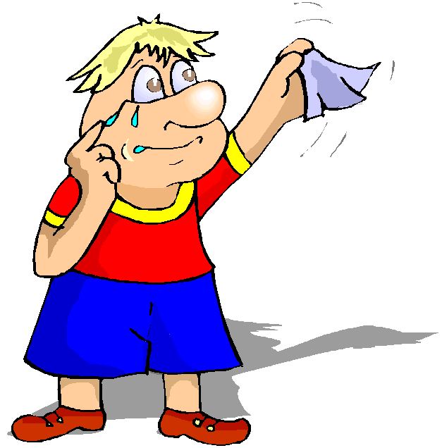
B: Nice talking to you too.
A: (I'll) see you later.
B: Alright. Bye.

A: It was nice talking to you.
B: Why are you trying to rush me off the phone?
A: I really have to go.
B: Why? I still wanted to talk to you.
A: I have things to do.
B: Like what?
A: Don't be nosey.
B: I'm not. I just want to know.
A: Well, it's really none of your business.
B: That's harsh.
A: I'm sorry, but I have to go.
B: Fine.

A: Oh, look at the time. I´ll have to go.
B: It’s been great talking to you.
A: We have to make plans to get together some time.
B: Yeah. Let’s do something some time.
A: Alright. I’ll call you.

Note: After one of the speakers has spoken the first words to end a conversation, it is appropriate for the other speaker (s)to say words like: ok, fine, alright, well, and then, the good-byes.
Activity 2: How would you close a conversation in the following situations? Create conversations in pairs or in groups.
a. You're in a hurry to leave. What do you say?
b. You really don't want to leave, but you can see the other person needs to go.
c. You just met someone at a party, but you have to leave the party early.
d. You have to say good-bye to your husband/wife, boyfriend/girlfriend.

Activity 3: Follow-up (homework):
1. Observe or listen to a natural conversation and write it down. Focus on the final stage of the conversation, where the closing part happens.
2. Analyze the conversation according to the following criteria:
- Where is the conversation happening? What is its purpose? What is the relationship between the speakers?
- How do the speakers let each other know that they are about to say “good-bye”? What formulas do they use to accomplish this? How do they avoid being rude and abrupt in closing the conversation?
- Which utterances are leave-takings or good-byes? How does the relationship between the speakers, their roles, the context of the conversation, and its purpose influence the choice of words for these utterances?
- Role-play the conversation in front of your classmates and present the results of your discussions.

Helped by: http://www.eslgold.com/speaking/ss_closing_conversation.html
http://www.eslgold.com/business/useful_expressions/closing_conversation.html
http://www.eslfast.com/robot/topics/smalltalk/smalltalk23.htm
http://www.indiana.edu/~dsls/publications/Griswold.pdf
http://www.better-english.com/grammar/bye.htm

