Simpsons Family Quiz
NAME _______________________________ DATE_________________ SEMESTER______
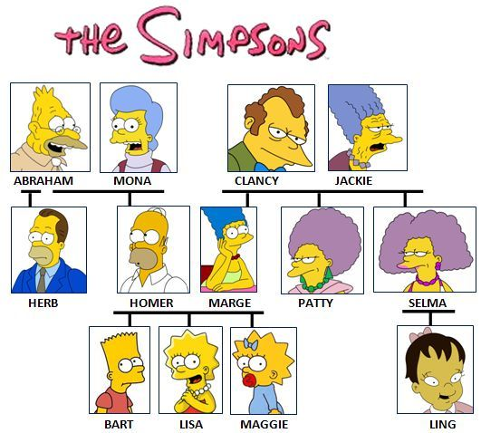
How much do you know about the Simpsons Family? Read the sentences and choose the correct options.
The picture above might help you.
- Bart is Lisa's ______________________  - Marge is Homer's__________________  - Clancy is Selma's ____________________  - Abraham is Mona's __________________  - Maggie is Ling's _____________________  - Lisa is Patty's ______________________  - Homer is Abraham's ________________  - Selma is Ling's ______________________  - Bart is Herb's ______________________  - Maggie is Marge's __________________  - Herb is Marge's ____________________  - Patty is Selma's _____________________ | - Herb is Homer's _____________________  - Abraham is Marge's _________________  - erb is Maggie's ______________________  - Jackie is Homer's ______________________  - Marge is Herb's ______________________  - Homer and Marge are Lisa's ______________  - Homer is Clancy's ______________________  - Bart and Lisa are Maggie's _______________  - Abraham is Lisa's ______________________  - Bart and Lisa are Marge's________________  - Maggie is Jackie's ______________________  - Marge is Mona's ______________________  - Clancy and Jackie are Bart's_______________

